**Is AJAX still relevant today?**

Yes.

Every single SPA that you use or app where there is partial page load still uses AJAX techniques today. However, how you write AJAX may change based on what libraries or frameworks you are using in your project.

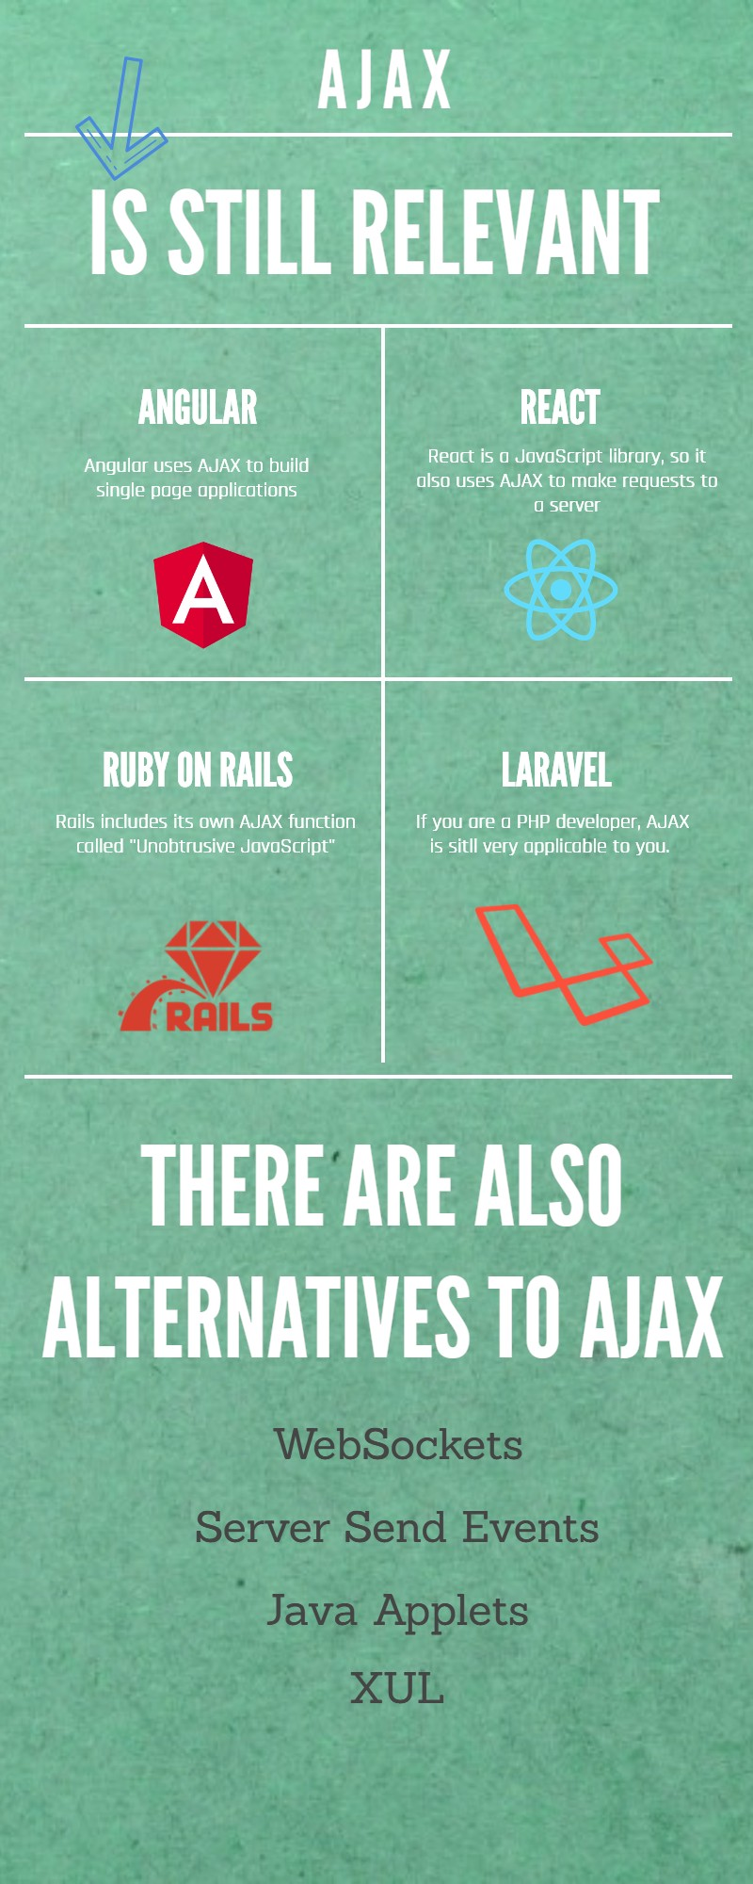Is AJAX still relevant today?

So there you have it.

AJAX is still awesome and very much relevant.

See you in the next lecture.